🔹 Introduction – Why Screenshots Are Important in Test Automation
- Screenshots act as visual proof of what happened during test execution.
- They are very useful when a test fails because they show the actual browser state at the moment of failure.
- In real projects, screenshots are often shared with developers, QA managers, or attached to bug reports for faster debugging.
- Even for successful steps, screenshots help in documentation and evidence of testing.

🔹 Explanation – How Screenshots Work in BDD Cucumber with Selenium Java
- Selenium provides the TakesScreenshot interface, which allows capturing the current browser view.
- In Cucumber, we can capture screenshots inside step definitions (for pass/fail conditions).
- The screenshots can then be saved to a local folder or embedded in the Cucumber report (if enabled).
- Since we’re not using Hooks or Extent Reports here, we’ll keep it simple and step-based.

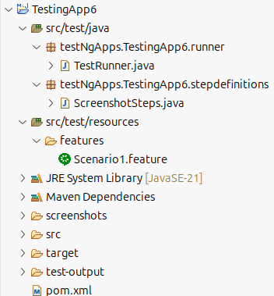
🔹 Step-by-Step Example – Project Structure + Flow

POM.xml:
<!-- Selenium -->
<dependency>
<groupId>org.seleniumhq.selenium</groupId>
<artifactId>selenium-java</artifactId>
<version>4.19.1</version>
</dependency>
<!-- Cucumber -->
<dependency>
<groupId>io.cucumber</groupId>
<artifactId>cucumber-java</artifactId>
<version>7.14.0</version>
</dependency>
<dependency>
<groupId>io.cucumber</groupId>
<artifactId>cucumber-testng</artifactId>
<version>7.14.0</version>
</dependency>

Scenario1.feature
Feature: Screenshot Demo

Scenario: Capture a screenshot of the Google homepage
Given I navigate to the Google homepage
When I capture a screenshot of the page
Then a confirmation should be displayed indicating the screenshot was taken successfully

ScreenshotSteps.java
package testNgApps.TestingApp6.stepdefinitions;

import java.io.File;
import java.io.IOException;
import java.nio.file.Files;
import java.nio.file.StandardCopyOption;
import org.openqa.selenium.OutputType;
import org.openqa.selenium.TakesScreenshot;
import org.openqa.selenium.WebDriver;
import org.openqa.selenium.chrome.ChromeDriver;
import io.cucumber.java.en.Given;
import io.cucumber.java.en.Then;
import io.cucumber.java.en.When;

public class ScreenshotSteps {
private WebDriver driver;
private String screenshotSavedPath;

@Given("I navigate to the Google homepage")
public void i_navigate_to_the_google_homepage() {
driver = new ChromeDriver(); // make sure chromedriver is in PATH
driver.manage().window().maximize();
driver.get("https://www.google.com");
}

@When("I capture a screenshot of the page")
public void i_capture_a_screenshot_of_the_page() {
// Cast driver to TakesScreenshot
TakesScreenshot ts = (TakesScreenshot) driver;

// Capture screenshot and store as file format
File src = ts.getScreenshotAs(OutputType.FILE);

// Define destination path
File dest = new File("screenshots/google_homepage.png");
dest.getParentFile().mkdirs(); // create folder if not exists

// Copy file to destination
try {
Files.copy(src.toPath(), dest.toPath(), StandardCopyOption.REPLACE_EXISTING);
} catch (IOException e) {
e.printStackTrace();
}

screenshotSavedPath = dest.getAbsolutePath();
System.out.println("Screenshot saved at: " + dest.getAbsolutePath());
}

@Then("a confirmation should be displayed indicating the screenshot was taken successfully")
public void a_confirmation_should_be_displayed_indicating_the_screenshot_was_taken_successfully() {
System.out.println("Screenshot saved at: " + screenshotSavedPath);
driver.quit();
}
}

TestRunner.java
package testNgApps.TestingApp6.runner;

import io.cucumber.testng.AbstractTestNGCucumberTests;
import io.cucumber.testng.CucumberOptions;

@CucumberOptions(features = "src/test/resources/features", glue = "testNgApps.TestingApp6.stepdefinitions")
public class TestRunner extends AbstractTestNGCucumberTests {
}

